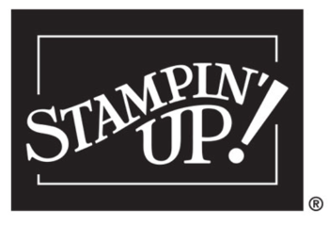

MY SHOPPING LIST

Name:____________________________________________

ID# | DESCRIPTION | PAGE | PRICE

ORDER ANYTIME! SHOP ONLINE 24/7
https://stampwithrachel.com
Contact me for questions or to place an order
(479)6 44-3318 or rachelbrumley@cox.net
Visit my website at: https://stampwithrachel.com

HOSTESS REWARDS

When you (and/or your friends combined) order $150 or ore at one time, you earn “hostess rewards” from Stampin’ Up!

Order Total before shipping and taxes | Free Merchandise | Half Price Items
$150 | 10%
$300 | 12%
$450 | 14%
$600 or more | $16% | !

Get your “wishes” at a discount:
Give Stampin’ Up! a try and never pay full price again. Ask me about our no obligation “try it kit”

Join my team as a demonstrator for only $99
- Choose $125 in Stampin’ Up! products of your choice
- Get free shipping on your starter kit order
- Enjoy a 20% at the beginning and 25% to $38% discount/commission on all orders
- No obligation to hold parties
- No obligation to continue after kit purchase
- No penalty for dropping

Shop with me for a reward:
- Use the monthly Host Code when you order
- If you are is over $150 do not use it so that you can take advantage of your own shopping rewards. I’ll still send you a gift.

